**A**

**MINI PROJECT REPORT**

**on**

**Online-Library**

**BE(IT)-III Sem**

**By**

**B Anuraag (160120737147)**

**D V Dheeraj (160120737148)**

**Under the guidance of**

**Mr G Srikanth**

**Assistant Professor**

**IT Department**



**DEPARTMENT OF INFORMATION TECHNOLOGY   
CHAITANYA BHARATHI INSTITUTE OF TECHNOLOGY (A)**

**(Affiliated to Osmania University; Accredited by NBA(AICTE) and NAAC(UGC), ISO Certified 9001:2015)**

**KOKAPET(V),GANDIPET(M),RR District HYDERABAD - 75**

**Website:** [**www.cbit.ac.in**](http://www.cbit.ac.in/)

**2021-2022**



**CERTIFICATE**

This is to certify that the project work entitled “**Online Library**” submitted to CHAITANYA BHARATHI INSTITUTE OF TECHNOLOGY, in partial fulfillment of the requirements for the completion of Mini Project-I of  III Semester B.E. in Information Technology, during the Academic Year 2021-2022, is a record of original work done by **B Anuraag (160120737147) and D V Dheeraj (160120737148)** during the period of study in the Department of IT, CBIT, HYDERABAD, under our guidance.

| **Project Guide** | **Head of the Department** |
| --- | --- |
| **Mr. Srikanth** | **Dr K Radhika** |
| Assistant Professor, Dept. of IT, | Professor, Dept. of IT, |
| CBIT, Hyderabad. | CBIT, Hyderabad. |

## ACKNOWLEDGEMENTS

We would like to express our heartfelt gratitude to **Mr G Srikanth** our project guide, for her invaluable guidance and constant support, along with her capable instruction and persistent encouragement.

We are grateful to our Head of Department, **Dr K Radhika**, for her steady support and for the provision of every resource required for the completion of this project.

We would like to take this opportunity to thank our Principal, **Dr P Ravinder Reddy**, as well as the Management of the Institute, for having designed an excellent learning atmosphere.

Our thanks are due to all members of the staff and our lab assistants for providing us with the help required to carry out the groundwork of this project.

**ABSTRACT**

A library plays a momentous role in the passage of knowledge. During ancient times a lot of books were stored in huge libraries, thus resulting in passage of information even when kingdoms and dynasties collapsed.

A library is said to be well functional if it can maintain vast collection of books and journals. A librarian should maintain a record of large number of books and journals available.

It becomes a laborious task for the management staff as they must be present physically when a student is returning a book. Moreover, maintaining registers all the time might be difficult. This project is hence aimed at reducing extra effort and time spend in library as a user must come up with many physical constraints.

The project “Online Library” allows a user to download a vast number of books. A user after registering is entitled to download, and add books, so that the collection is updated day by day.

Owing to the advancement of technology, organization of an Online Library becomes much simple. This computerization of library helps in many instances of its maintenances. It reduces the workload of management as most of the manual work done is reduced.

**TABLE OF CONTENTS**

| **S NO** | **TOPIC** | **Page No** |
| --- | --- | --- |
|  | **TITLE** |  |
|  | **CERTIFICATE** |  |
|  | **ACKNOWLEDGMENT** |  |
|  | **ABSTRACT** |  |
| 1. | **INTRODUCTION** |  |
|  | 1.1 INTRODUCTION | 7 |
|  | 1.2 MOTIVATION | **7** |
|  | 1.3 PROBLEM STATEMENT | **7** |
|  | 1.4 OBJECTIVE | **7** |
|  | 1.5 APPLICATIONS | 7 |
|  | 1.6 ORGANISATION OF REPORT | **8** |
|  |  |  |
| **2** | **LITERATURE SURVEY**  **2.1 Software Requirements**  **2.2 Hardware Requirements**  **2.3 Existing System** | **9**  **9**  **9** |
|  |  |  |
| **3** | **SYSTEM DESIGN OR METHODOLOGY**  **3.1 FUNVTIONAL REQUIRMENTS**  **3.2 SYSTEM ARCHITECTURE**  **3.3 BLOCK DIAGRAM** | **10**  **10**  **11** |
|  |  |  |
| **4** | **IMPLEMENTATION** | **13** |
|  |  |  |
| **5** | **TESTING AND RESULTS** | **40** |
|  | **5.1 Register Page** | **40** |
|  | **5.2 LOGIN PAGE**  **5.3 FORGOT PASSWORD** | **41**  **41** |

| **S NO** | **TOPIC** | **Page No** |
| --- | --- | --- |
|  | **5.4 HOME PAGE** | **42** |
|  | **5.5 HELP US** | **44** |
|  | **5.6 ADMIN PAGE** | **45** |
|  |  |  |
| **6** | **CONCLUSIONS AND FINDINGS**  **6.1 CONCLUSION**  **6.2 LIMITATIONS**  **6.3 FUTURE SCOPE** | **47** |
|  |  |  |
| **7** | **BIBLIOGRAPHY** | **48** |
|  |  |  |
|  |  |  |
|  |  |  |
|  |  |  |
|  |  |  |
|  |  |  |
|  |  |  |
|  |  |  |
|  |  |  |
|  |  |  |
|  |  |  |
|  |  |  |
|  |  |  |
|  |  |  |

**List of Figures**

| **Figure No** | **Name of the Figure** | **Page No** |
| --- | --- | --- |
|  |  |  |
| 3.1 | ARCHITECTURE | 10 |
| 3.2  4.1  4.2  4.3  4.4  4.5  4.6  4.7  4.8  4.9  4.10  4.11  4.12  4.13  4.14  4.15  4.16  4.17  4.18  4.19  4.20  4.21  4.22  4.23  4.24  4.25 | BLOCK DIAGRAM  LOGIN PAGE  USER REGISTRATION  ONE TIME PASSWORD  PASSWORD  CSS STYLING  HOME PAGE  HELP US  ABOUT US  ADD BOOK  ADMIN  BACK-END CONNECTIVITY (DATABASE)  LOCAL HOST CONNECTIVITY | 11  12  14  16  18  20  23  28  31  33  36  38 |
|  |  |  |
|  |  |  |
|  |  |  |
|  |  |  |
|  |  |  |
|  |  |  |
| 5.1  5.2  5.3  5.4  5.5  5..6  5.7  5.8  5.9  5.10  5.11 | Registration Page  Code Verification  Login Page  Forgot Password  Home Page  List of Books (Department Wise)  Download Book  Downloaded Book On A Local Device  Downloaded Book View On Local Device  Help Us  Admin Page | 40  40  41  41  42  42  43  43  44  45  46 |
|  |  |  |
|  |  |  |
|  |  |  |
|  |  |  |
|  |  |  |
|  |  |  |
|  |  |  |
|  |  |  |
|  |  |  |
|  |  |  |
|  |  |  |

1. **INTRODUCTION**

**1.1 INTRODUCTION**

Books are the biggest source of knowledge ever since a human begin to think and innovate new things. Libraries thus played a pivotal role in improving the human standards as well as developing new civilizations. Nowadays, visiting a library during the pandemic is a risky job. It’s even riskier for the staff to manage books all time and have a physical contact with the books taken by a user. A student would find it a lot easier if a “Online Library” system is there.

* 1. **MOTIVATION**

The vision of this project is to create a library in which the student can access any number of books without any constraint, as the project is based on the ethos of making knowledge easily accessible. This project is aimed for the whole learning community, and it is the basic value of sharing which is the main motive behind this project. As the project is stressed on open-source contribution, each user can be a part of it by adding books. A user should mail the admin with a copy of a book, which then would be updated to the vast collection.

* 1. **PROBLEM STATEMENT**

A Librarian has a responsibility to keep the records of new books. He also must ensure that data of books in the library are up to date. He should keep track of the books issued to students and returned by the students. Moreover, he must not allow others to carryout tasks without permission.

Therefore, doing these tasks manually is very difficult and lot of time consuming. Hence it is needed to develop a system which can maintain all the records of the new books, update them and can update the details of books returned and issued to the students as per the requirement.

It also must have the facility of admin login so that no others can manipulate the data. There is a requirement to develop this type of system in a computerized way.

* 1. **OBJECTIVE**

The main objective of “Online Library” is to:

1. To analyze the needs of the school especially the library when it comes to reservation of book, borrowing of book, the inventory of book, the searching of books.
2. To design a system that fits the requirements of the school. A friendly G.U.I that the librarian and the students can easily use. A system that can access the database of books and students faster.
   1. **APPLICATIONS**

* The webpage makes it easier for the user to access every book in a single go.
* It is a safe experience especially during the pandemic
* Users don’t need to wait, it’s a responsive website
  1. **ORGANIZATION OF THE REPORT**

In project there are two sections which are divided as users and admin. The admin has the control to add books.

The mini- project is divided into six parts:

1. First part contains an introduction to the project.

2. Second part of the project contains the literature survey which consists of software

and hardware requirements and the existing system of the project.

3. Third part contains the methodology of the project and block diagram of the proposed

system.

4. Fourth part contains the implementation of the project this consists of the code used

for execution.

5. Fifth part contains the testing and results of the project. It consists of screenshots of

the execution of the project.

6. Sixth part contains the conclusion of the project and the future of the project.

1. **LITERATURE SURVEY**

**SOFTWARE REQUIRMENTS**

**2.1 LANGUAGES USED:**

Front-end: HTML, CSS & Bootstrap.

Back-end: PHP

Database: MySQL (MariaDB)

Server use: XAMPP

Code-Editor: Visual Studio Code

**2.2 HARDWARE:**

1. Operating System: Windows
2. Ram: 2GB Minimum (4GB Recommended)
3. Processor: 1.8 GHz or faster 64-bit processor
4. Storage: Minimum of 850 MB up to 210 GB of available space

**2.3 EXISTING SYSTEMS:**

* The availability of the book must be checked.
* The files need to be checked manually
* Each task must be automated by the librarian
* Updating of books and journals is a tedious task and time consuming
* The application is less secure and hence is highly vulnerable.
* As it is highly vulnerable, once exposed to cyber-attacks all the data would be lost.

1. **SYSTEM DESIGN OR METHODOLOGY**
   1. **FUNCTIONAL REQUIRMENTS:**

Our project consists of the following features:

* Admin Control Panel
* View of All Books in Online Library
* Add Book
* Edit Book
* Delete Book
* User – End
* Login Page
* User Registration (Sign-Up)
* Forgot Password with Password-Change
* Home Page
* View Book Page (To Download eBook)
* Help Us
* About Us
* Logout
  1. **SOFTWARE ARCHITECTRE:**

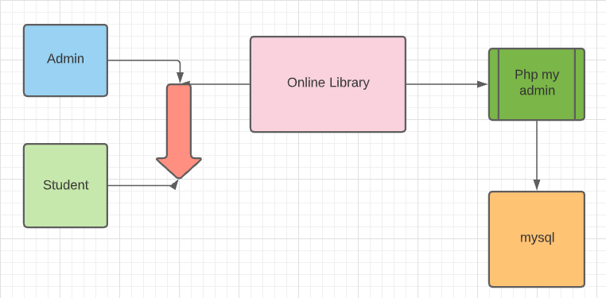

FIG 3.1 ARCHITECTURE

* 1. **BLOCK DIAGRAM:**

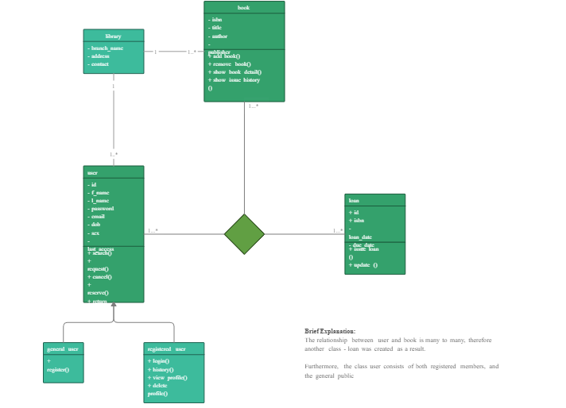

FIG 3.2 BLOCK DAUGRAM

**4.IMPLEMENTATION**

* The Web page of “Online-Library” is implemented in two sections:
* User Interface
* Administrator Interface
* **SIGN-UP PAGE**
* The Sign-Up page consists of 4 fields (Full Name, Email, Password, Confirm Password).
* Users need to fill all the fields to get registered.
* User needs to give a password that consists of a combination of Upper-case, Lower-case, Digit & Special Characters. Otherwise “Give a Strong Password Error is Echoed”.
* Make sure that Password and Confirm-Password fields are filled correctly, if there is no match between the fields “Confirm-Password not matched Error is Echoed”.
* If no errors occur, then OTP is generated and sent to the user’s email using SMTP and the user is redirected to the OTP page.
* Meanwhile the user data is stored in the database.

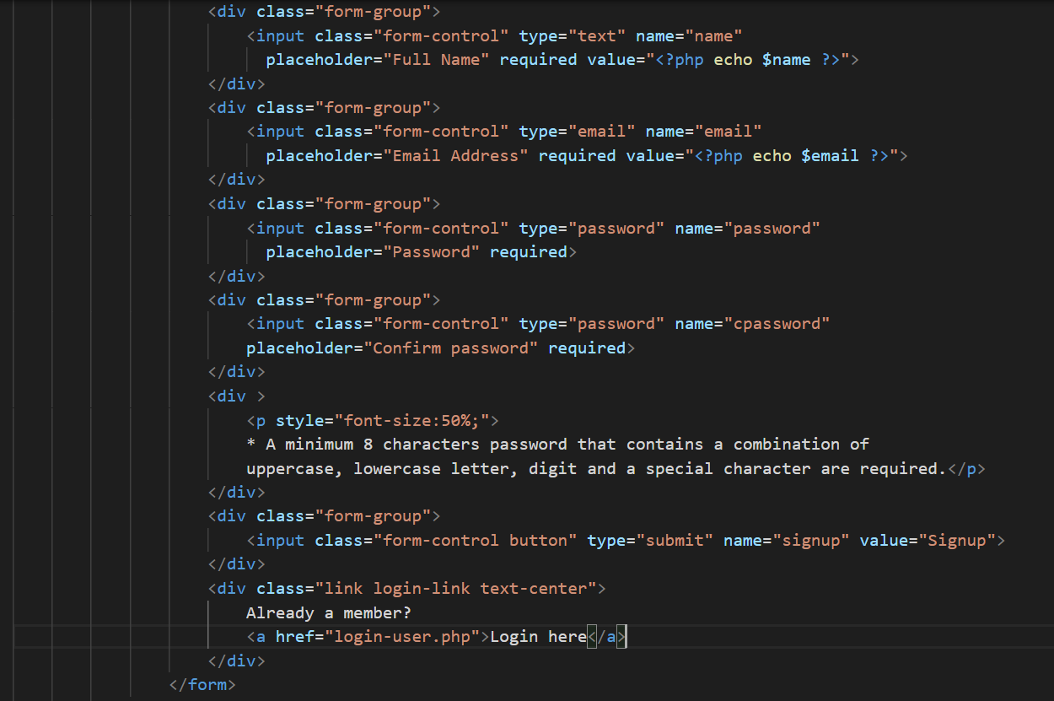

The Input fields of the Form

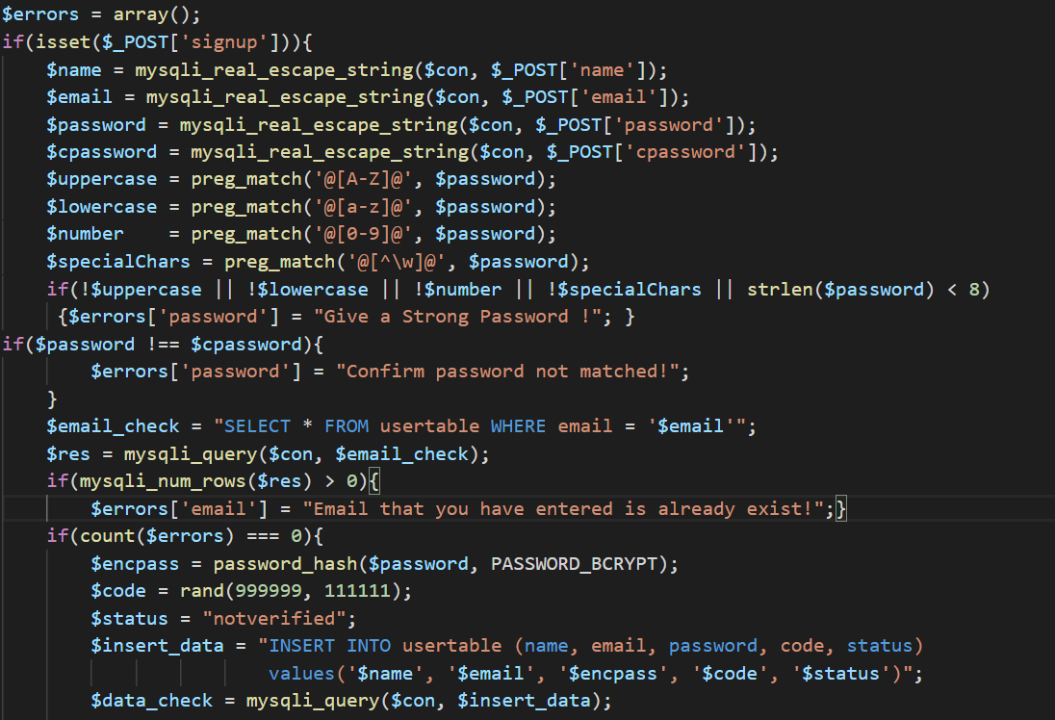

Process the provided information and check for errors in information provided

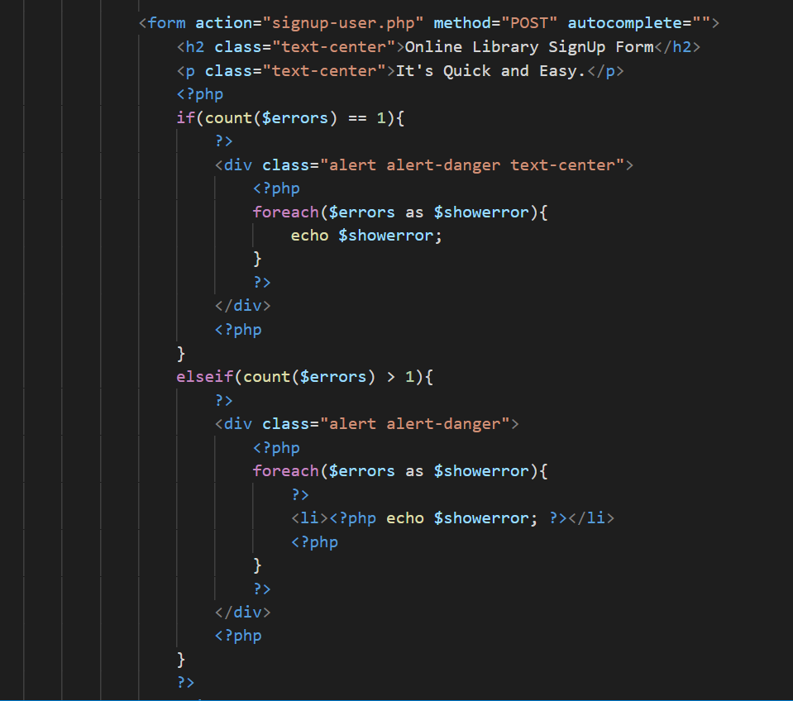

If any errors, display them in alert-box

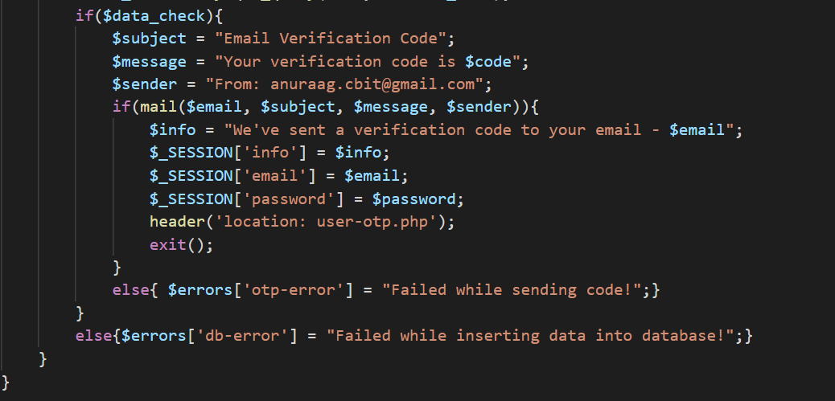

If no errors in information provided by user, then generated OTP is sent to user for verification

* **OTP-PAGE**
* User must enter the OTP sent to his mail.
* The OTP is checked with the OTP generated.
* If the entered OTP is correct the user becomes verified and is redirected to Dashboard of the Website.
* If the entered OTP is incorrect “OTP – Incorrect” error is echoed.

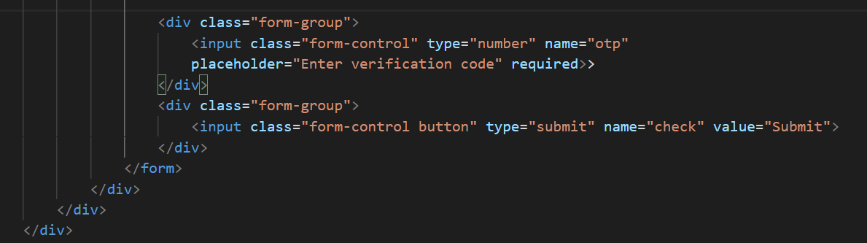

Take the OTP entered by the user for verification

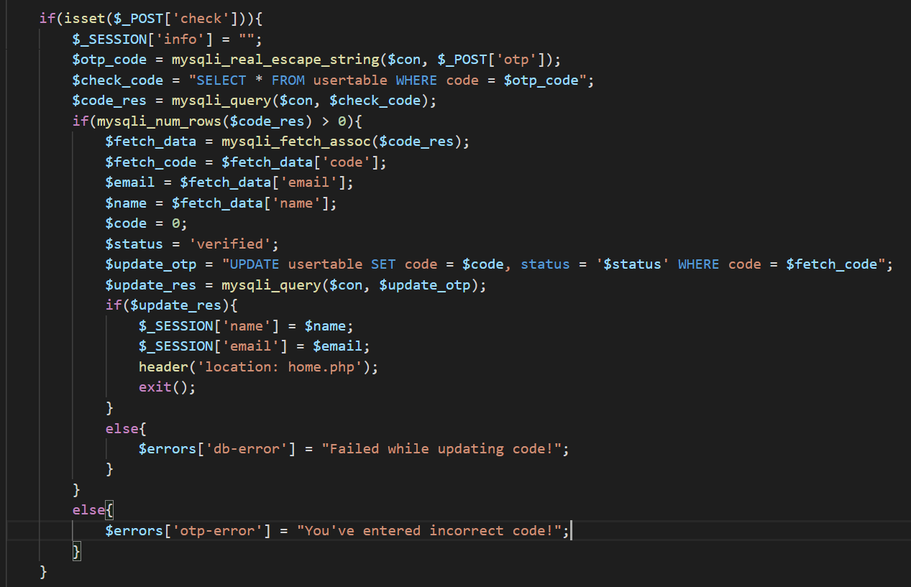

Check whether the OTP entered matches with the OTP generated.

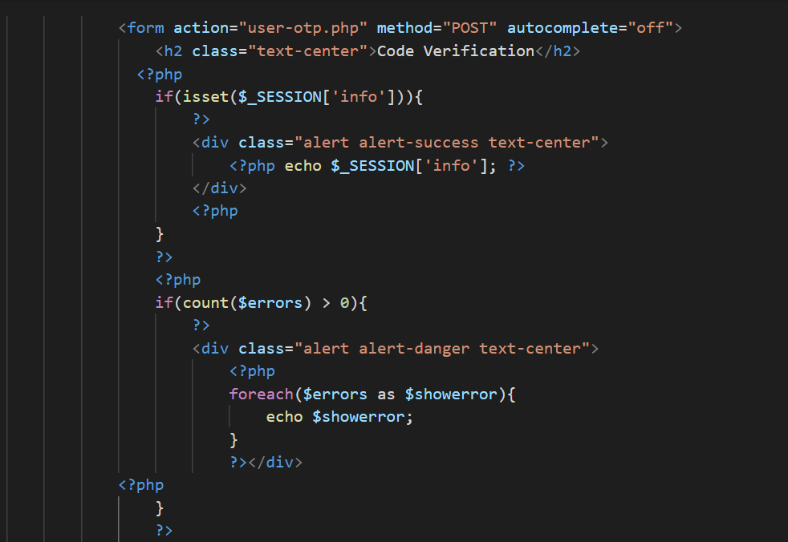

If OTP entered is incorrect then echo the error

* **LOGIN PAGE**
* Login Page consists of the fields (Email & Password)
* User needs to enter the fields and click on Login Button.
* Upon clicking Login Button, the email is checked in the database.
* If email not found, then echo “Not Registered with us” error.
* If email found, then check whether the password matches with the corresponding password in database.
* If email and password pair doesn’t match echo “Incorrect Password” error.
* If both email and password pair match give user access to Dashboard.
* Record the session with the user’s name and email provided.
* If the user is not yet registered, a link for Sign-Up page is also provided.
* If the user forgot his/her password a link for forgot password is also placed.

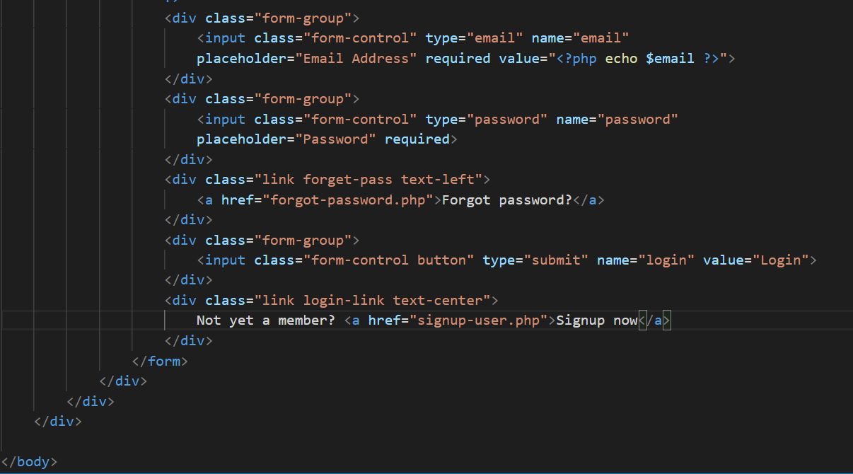

Input fields of Login Form

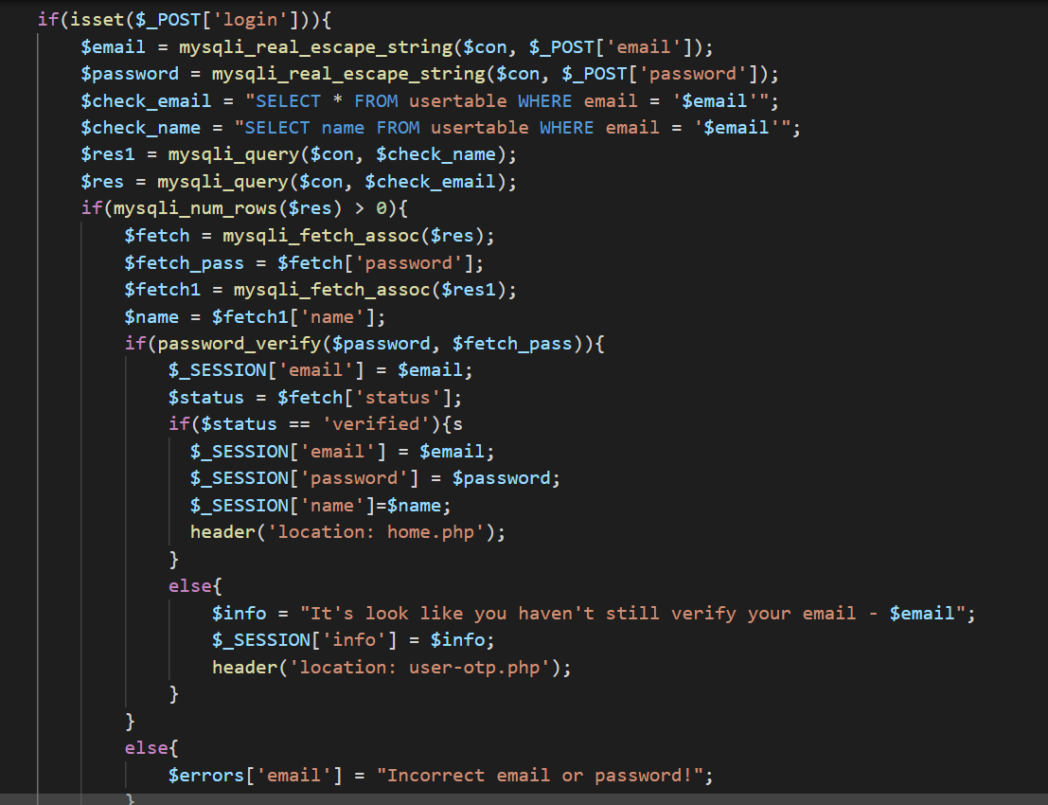

Check wheteher the email exists in database and email-password match

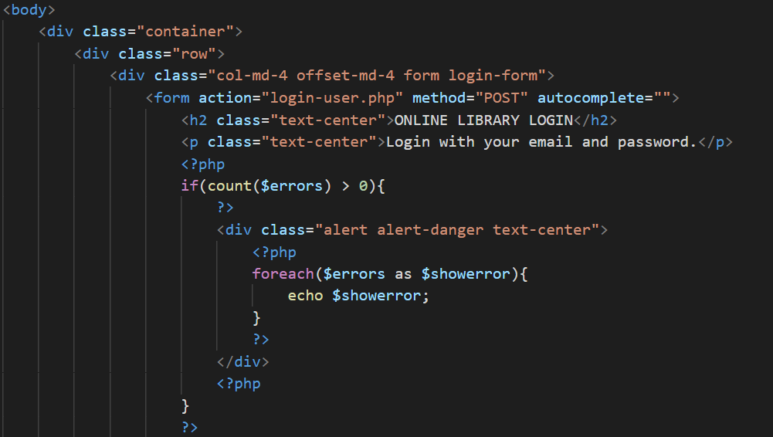

If email-password entered do not match echo “Incorrect Password” error.

* **FORGOT-PASSWORD**
* In case user forgot his/her password he can change it by clicking on the forgot-password link.
* The user must provide the email-id.
* The entered email is searched in the database.
* If the email entered is in the database an OTP is sent to the email.
* If the email entered is not in the database “Not Registered User” error is echoed.

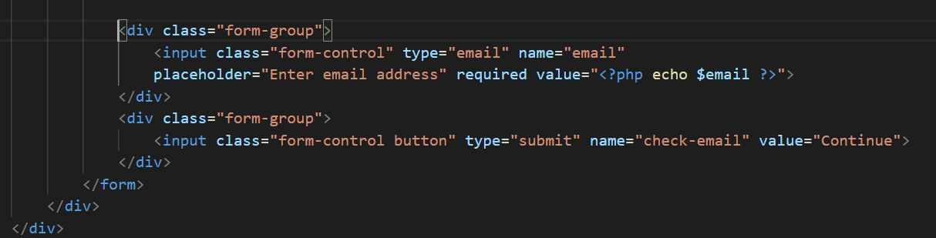

Input field for email to be provided

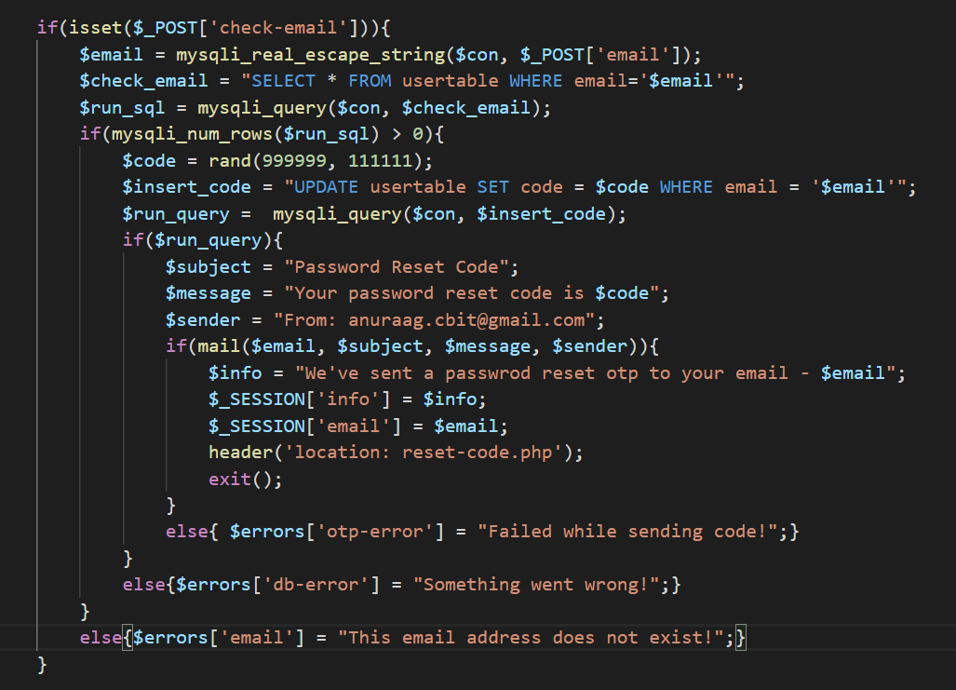

Entered email is checked in the database if it exists a OTP is generated and sent to the email provided

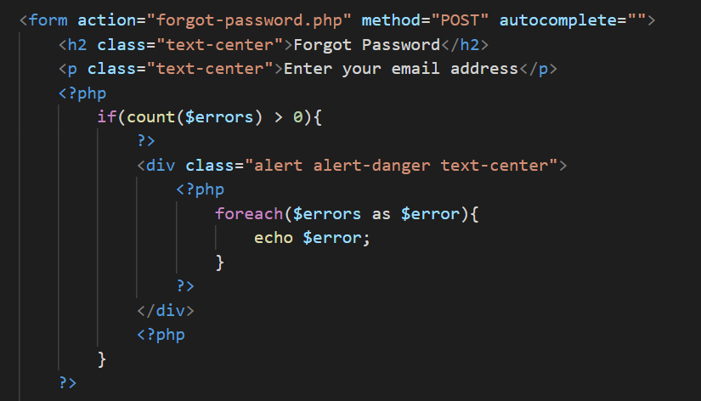

If provided email is not present in database echo error

* **RESET-OTP PAGE**
* The user must enter the OTP sent to his mail.
* The OTP entered is checked with the OTP generated.
* If entered OTP is correct, then give access to change password.
* If entered OTP is incorrect, echo “Incorrect OTP” error.

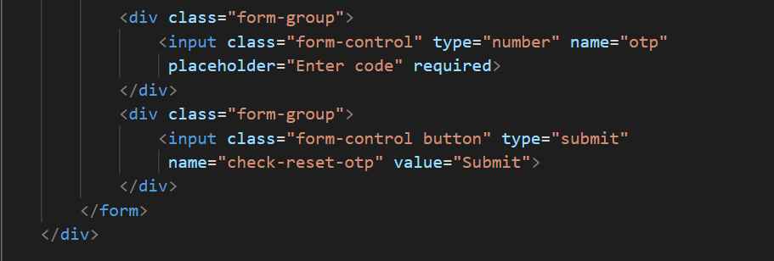

Input field for reset OTP

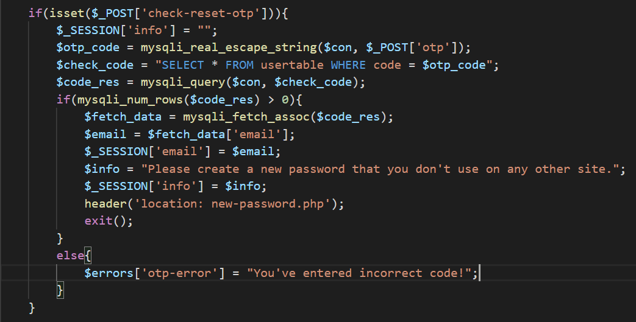

Check whether the entered reset-OTP is correct give access to New Password

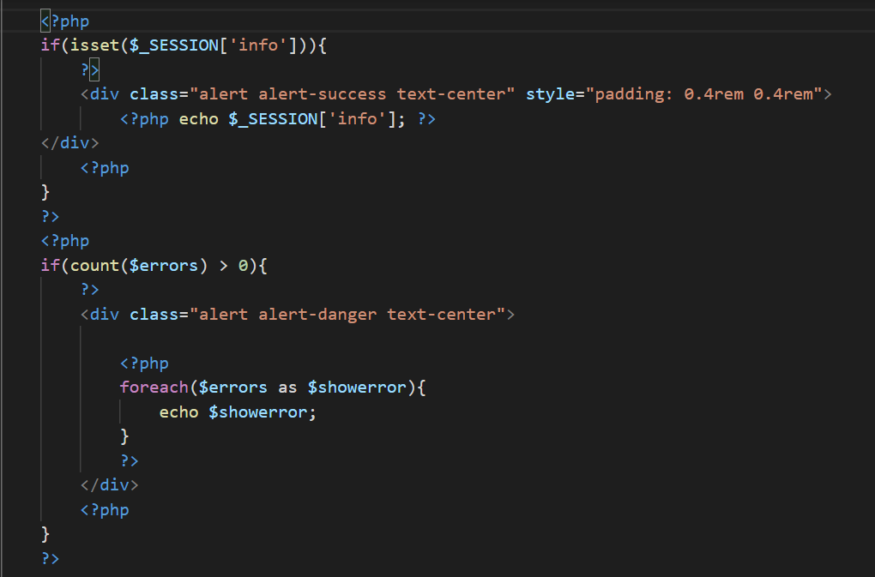

If reset OTP is not correct echo “Incorrect OTP” error

* **NEW PASSWORD**
* User must enter a new password abiding to the password constraints.
* If password doesn’t abide to password constraints echo “Give Strong Password” error.
* If password abides to password constraints update the new password and open password-changed page.

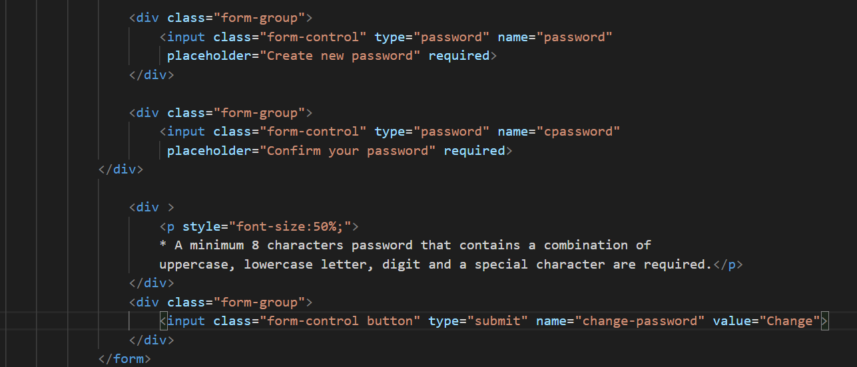

Input field for new password

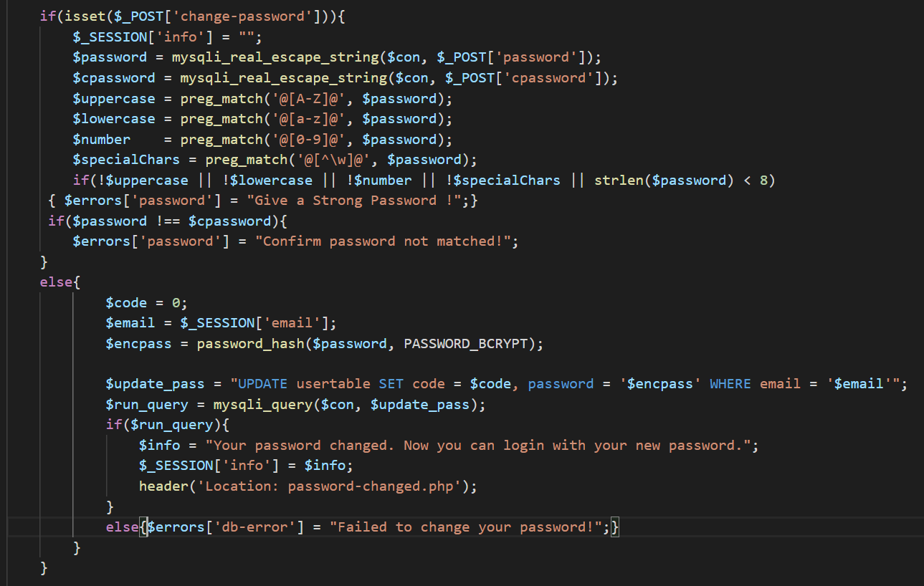

Check password constraints and update the new password if constraints met

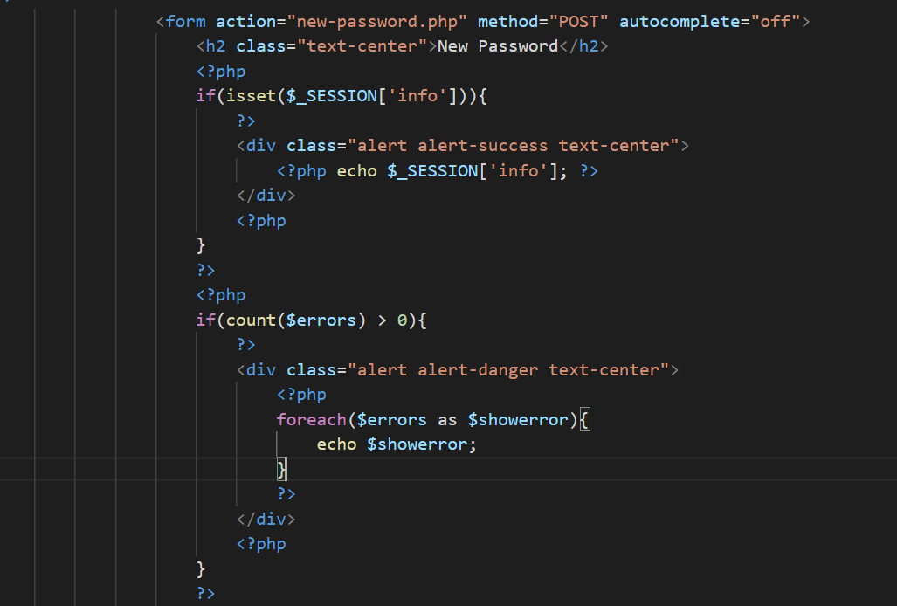

If password constraints do not meet, then echo “Give Strong Password” error

* **PASSWORD CHANGED PAGE**
* Upon successful change of password user can login with new password provided.
* On clicking on Log-In Now button user is redirected to Log-In page where he can login using new password.

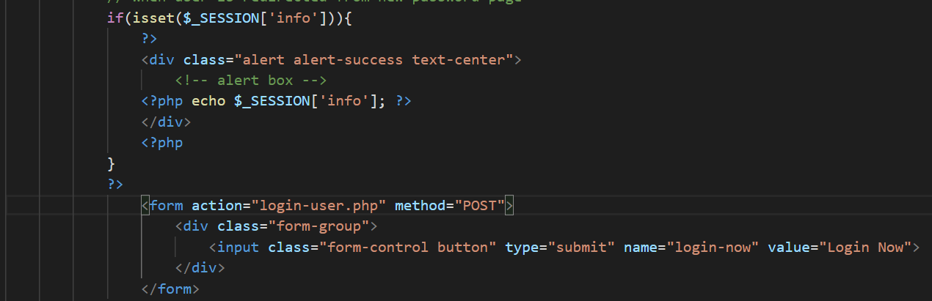

Session of the user is carried and user can access Login page by clicking the Login-Now Button

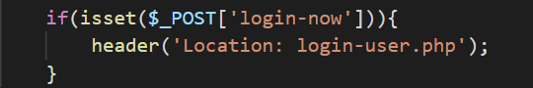

When Login-Now button is clicked the user is redirected to Login-Page

* **CSS STYLING OF LOGIN SYSTEM**
* Used Bootstrap for styling Login System.

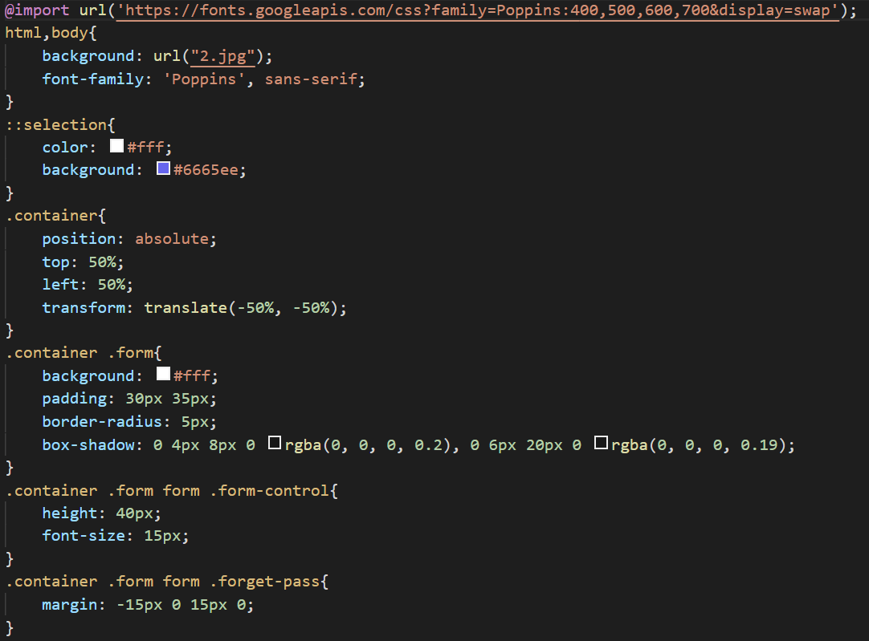

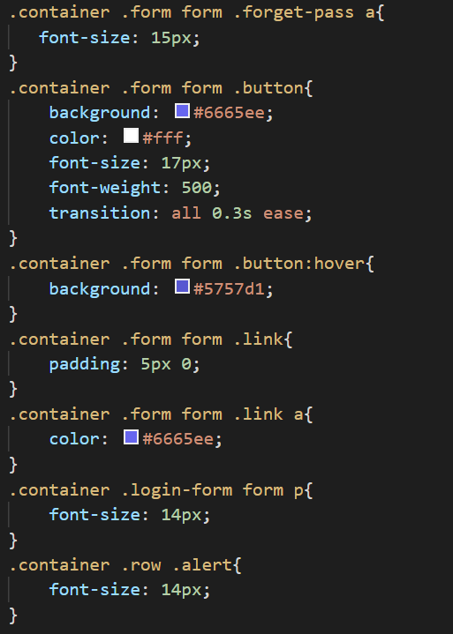

* **DASHBOARD**
* Upon Successful login the user gets access to our DASHBOARD.
* The eBooks are segregated department wise.
* Users can click on the book name to view the description of the book.

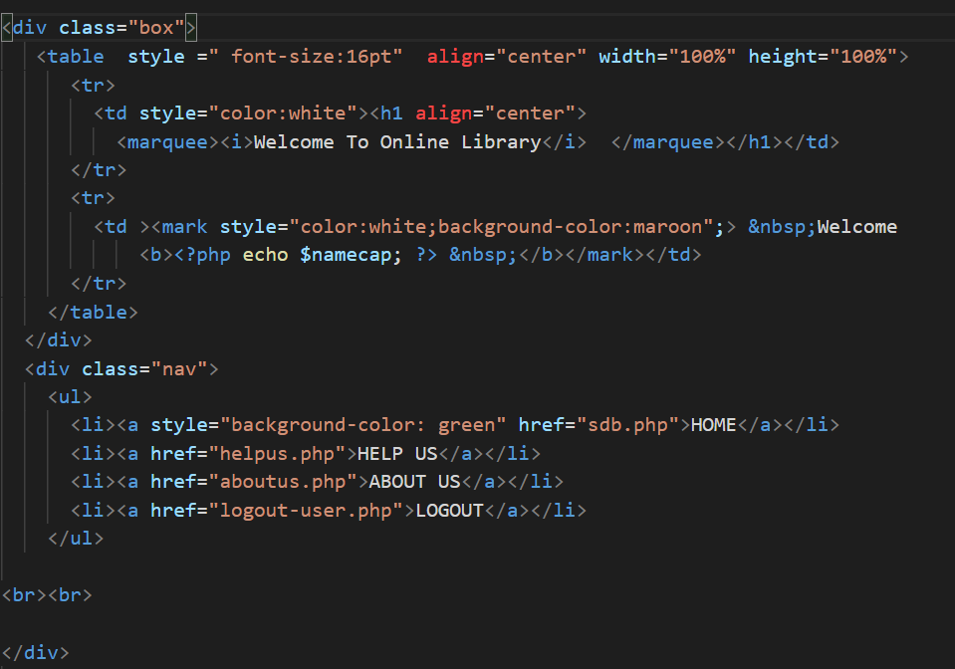

Title Box and Menu Bar(to access other pages)

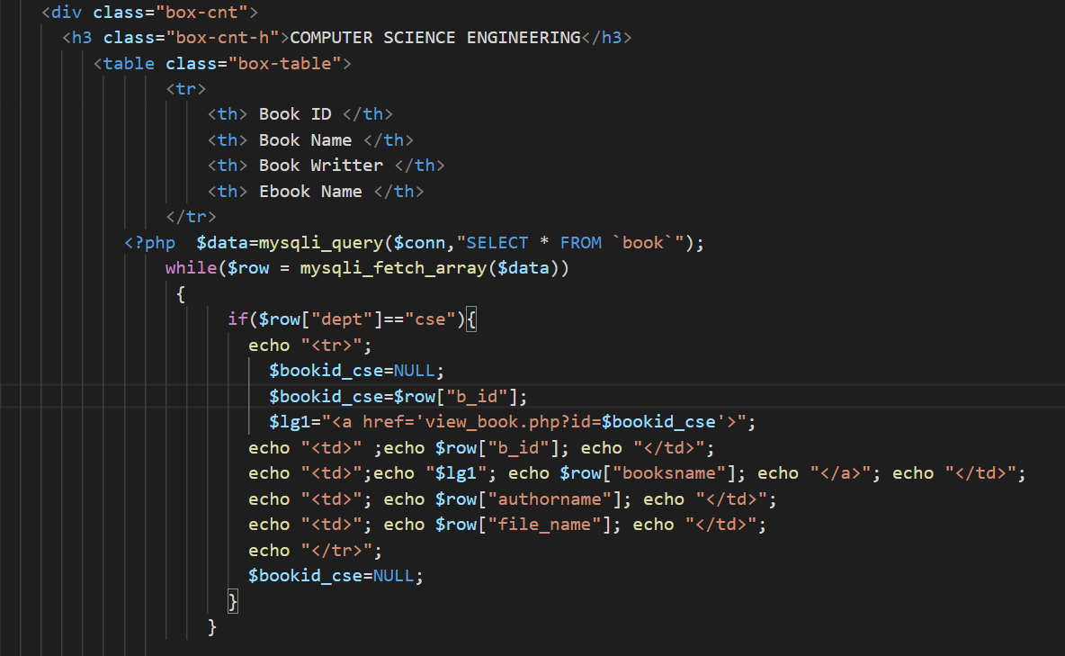

Computer Science Department Books

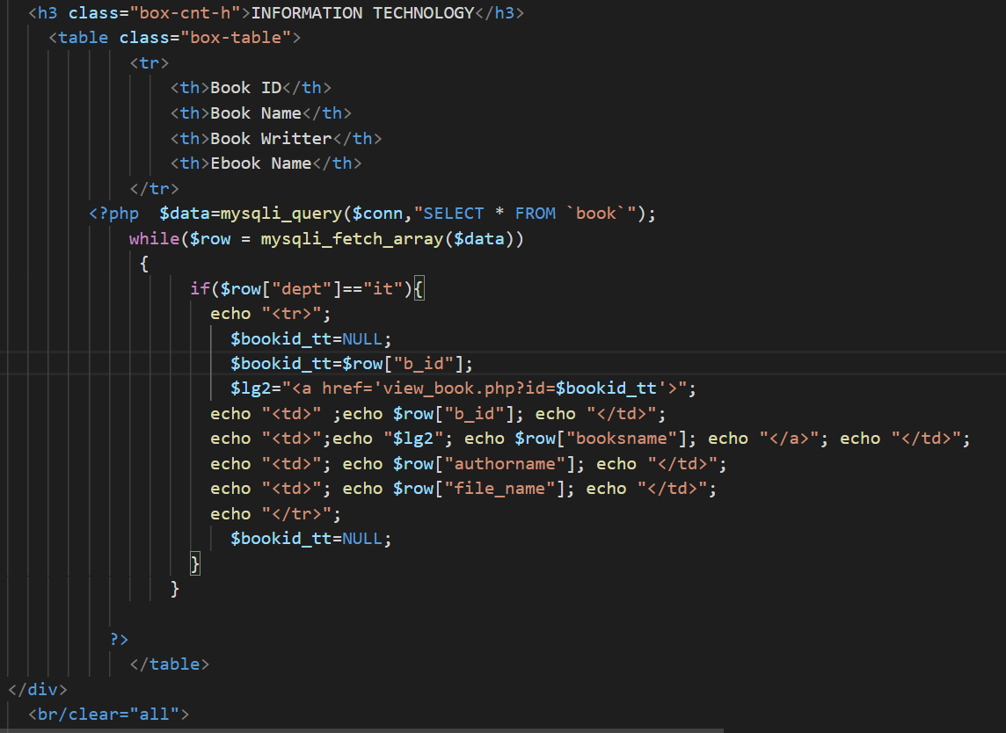

Information Technology Department Books

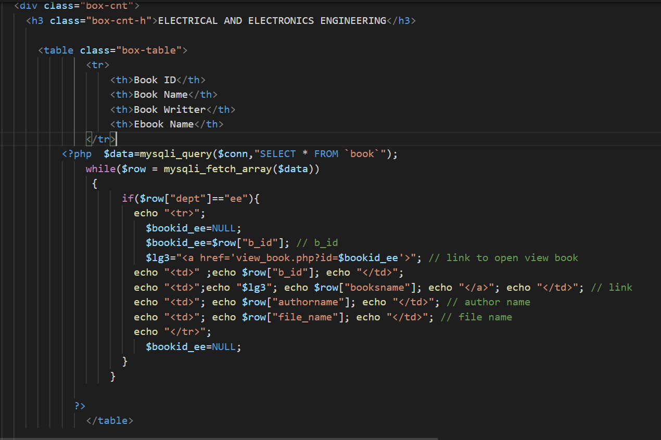

Electrical and Electronics Department Books

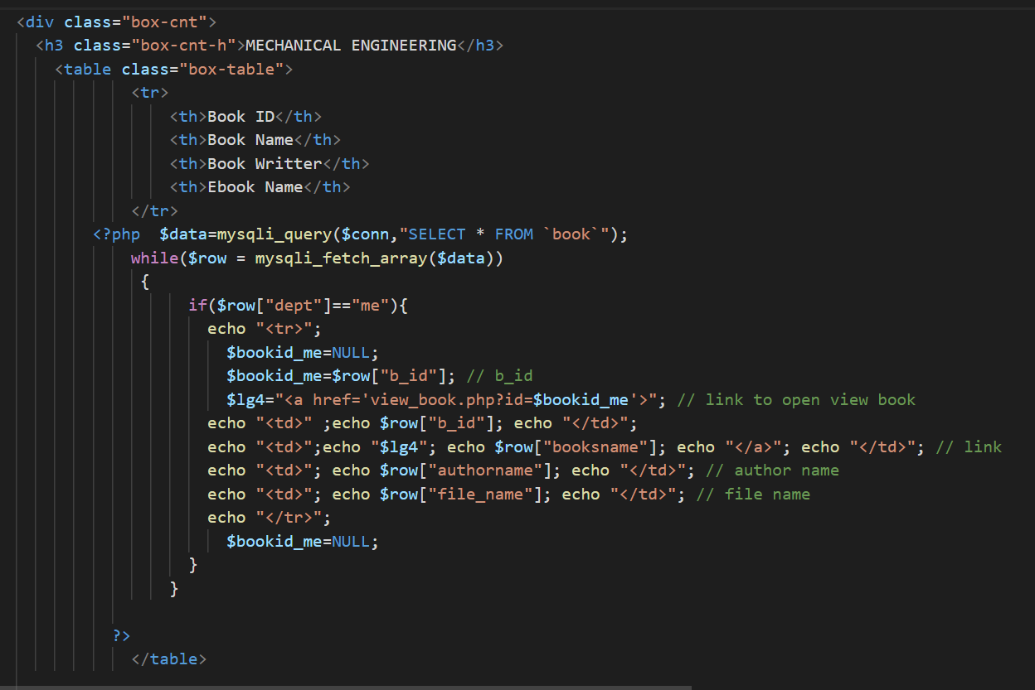

Mechanical Department Books

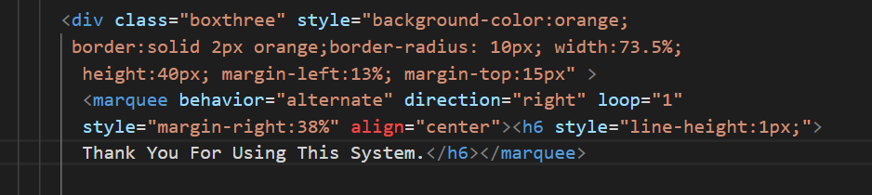

Thank You Box

* **HELP US**
* Users who have eBooks can contribute to our project by providing the books in department folders using google drive.

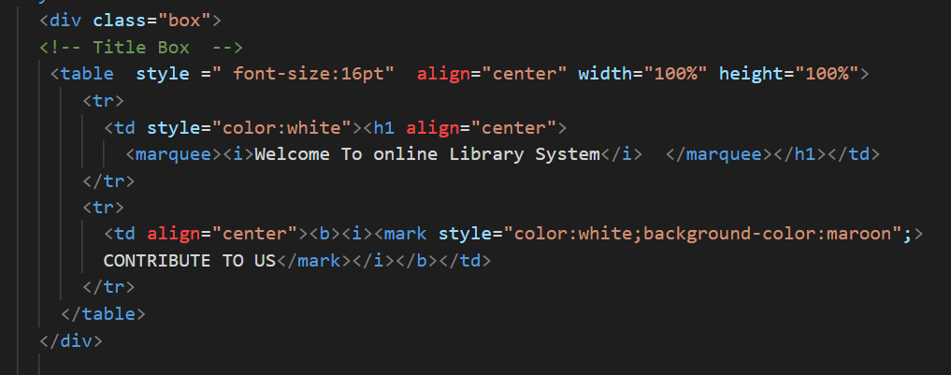

Title Box

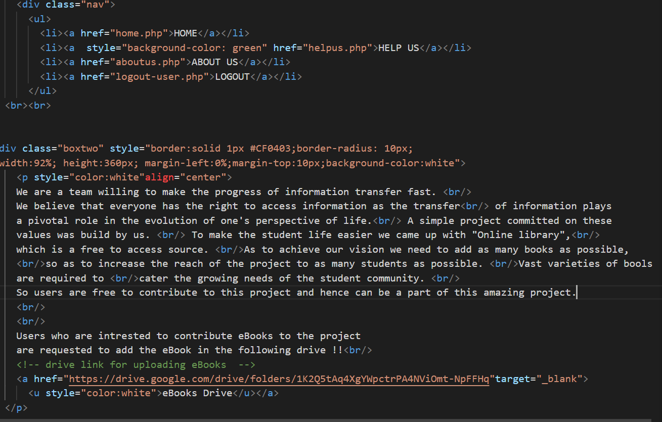

Message and Drive Link to provide eBooks

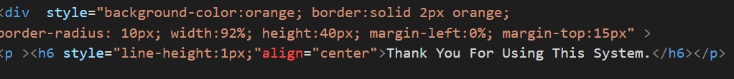

Thank-You Box

* **ABOUT US PAGE**
* It consists of Acknowledgement and Group members details.

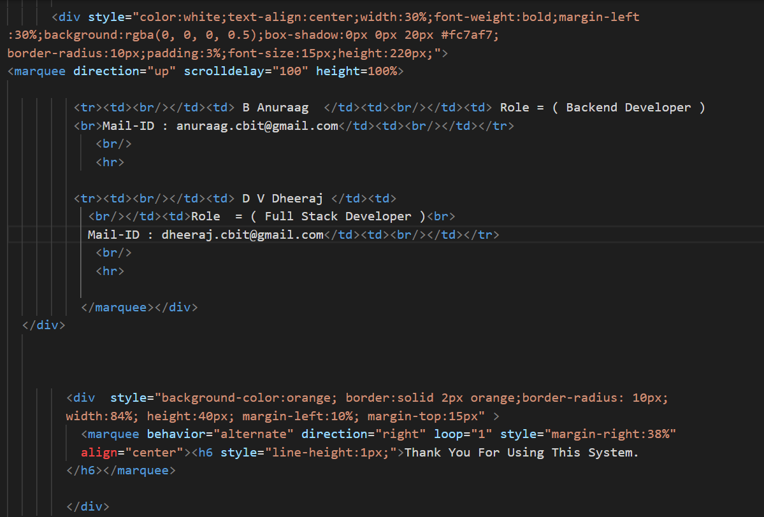

Acknowledgement and Group members details

* **VIEW BOOK PAGE**
* The user can view the description of the book by clicking on the name of the book on dashboard.
* Click on download button to download the eBook.

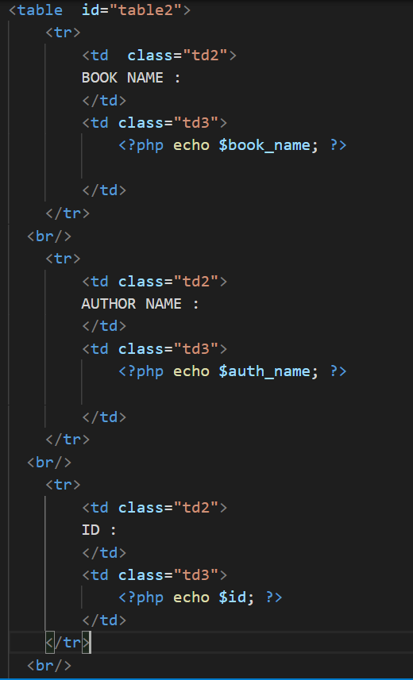

Description of the Book

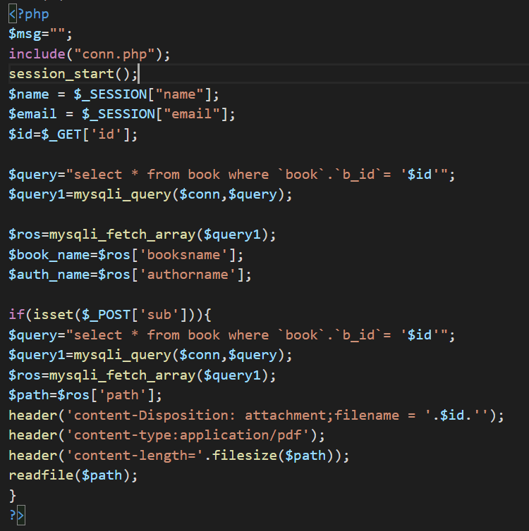

Download eBook

* **ADMIN SECTION**
* **ADMIN VIEW PAGE**
* Admin can view all the books available on the database.

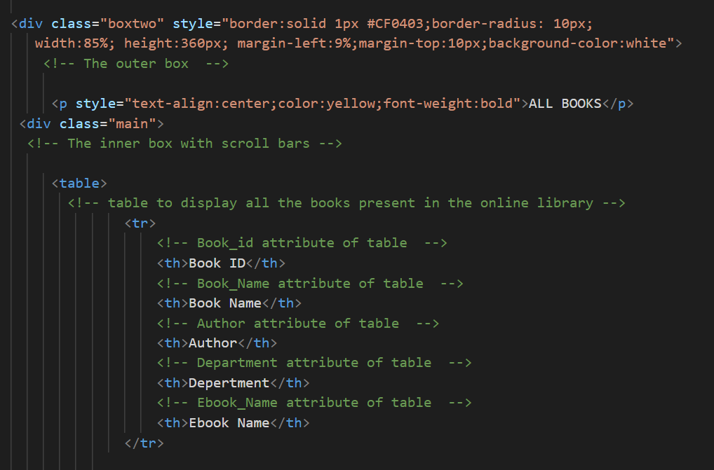

Admin can view all the books with their name, department, eBook name.

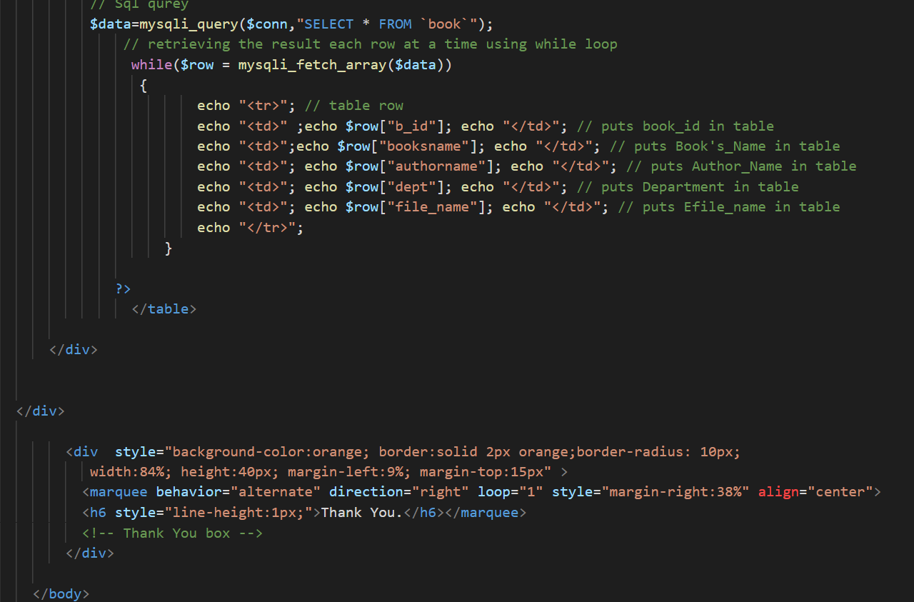

Books are displayed in a table

* **ADD BOOK**
* Admin can add books to the database providing book id(unique), book name, department.
* Then Admin should upload the file (only PDFs accepted)

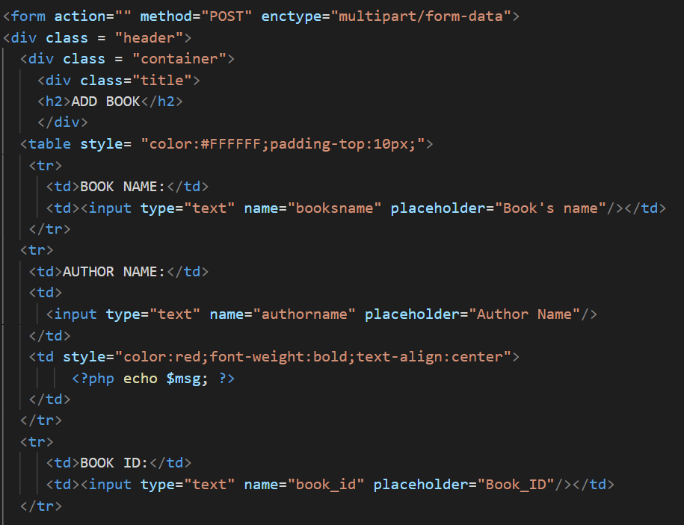

Input of fields required to be filled to add a book by the Admin

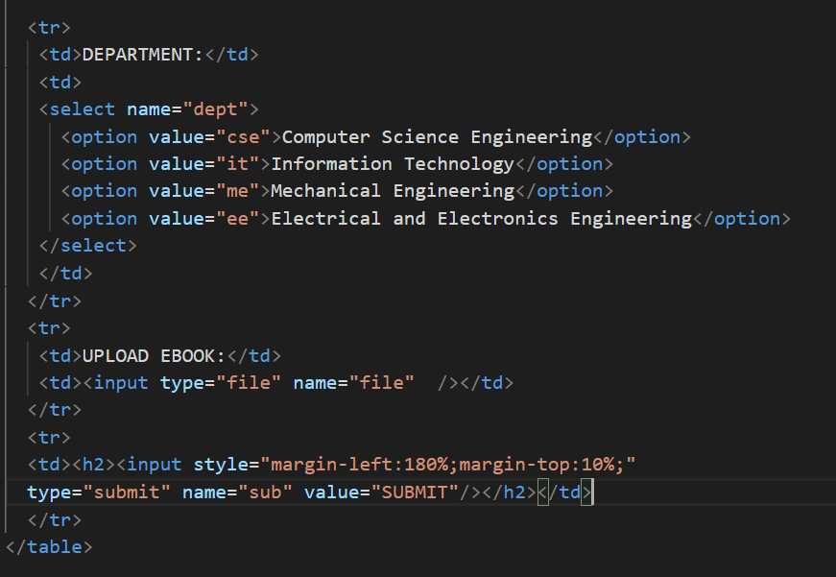

File Upload Input

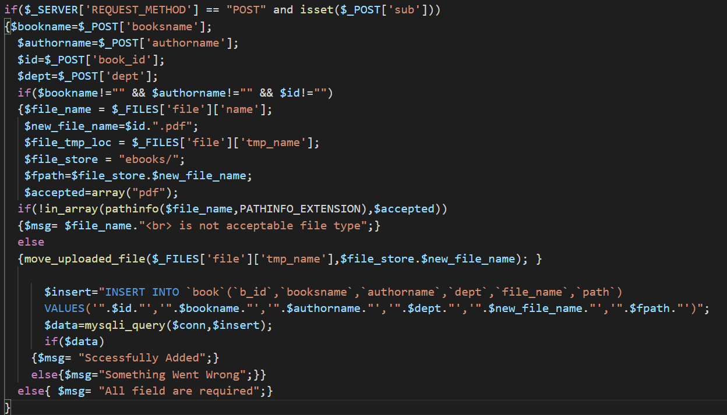

Add the book to the database if any error occurs echo the error

* **EDIT BOOK**
* Admin can Re-Upload a book if a new edition of the book is available.
* Admin should provide book id, book name, authorname, department and upload the file.

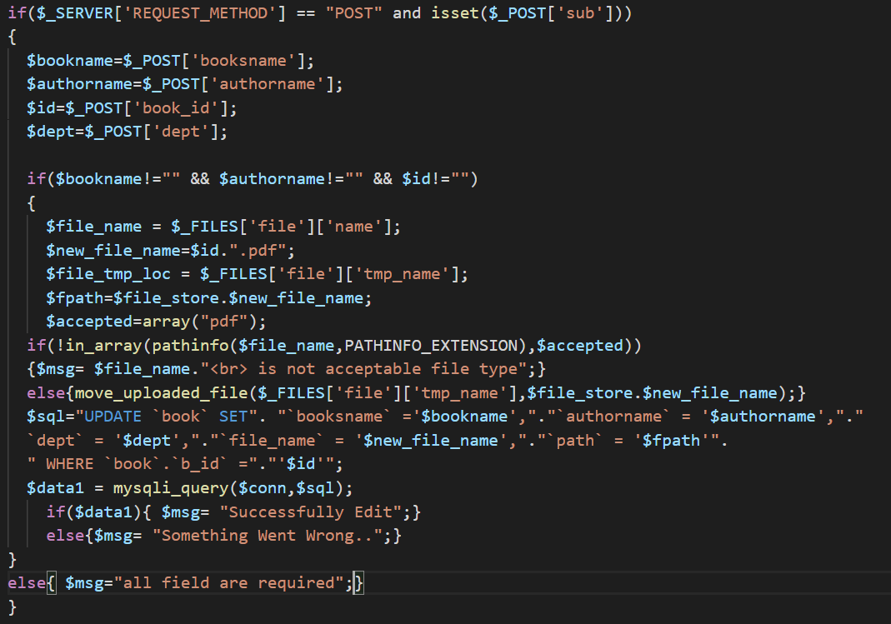

Edit Book

* **DELETE BOOK**
* Admin can delete the book using Book id.
* If book id not entered correctly echo “Unable to delete” error.

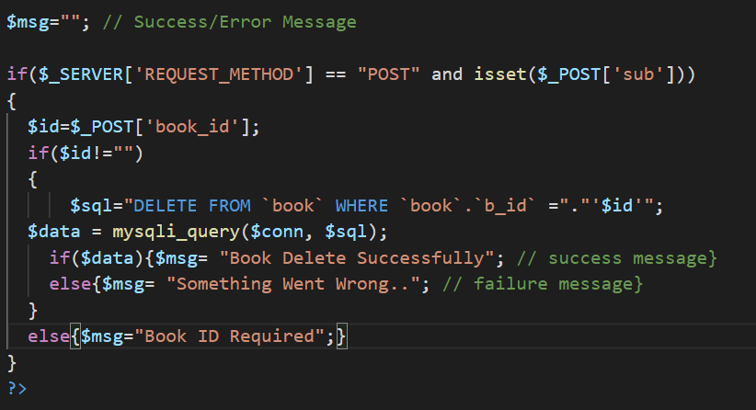

Delete Book

* **BACK-END CONNECTIVITY**
* There are two databases “Userform” for maintaining the user registration details and “lib” database for holding the eBooks of the Online Library.

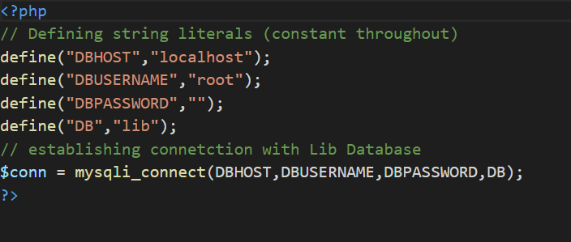

Connects to Lib Database

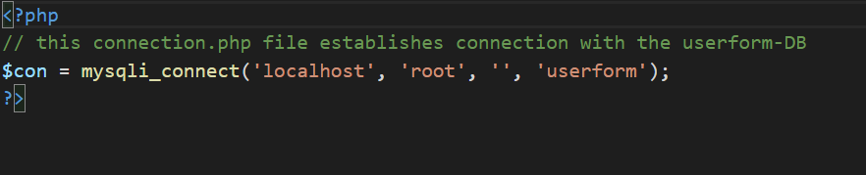

Connects to Userform Database

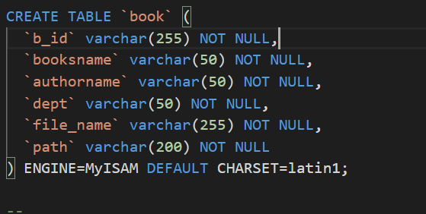

Book Table in Lib Database

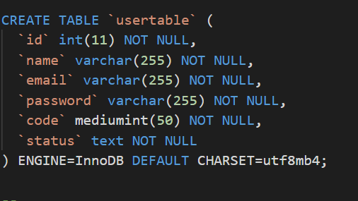

Usertable in Userform Database

* **Local Hosting**
* For Hosting on local system (local-host) XAMPP is used.

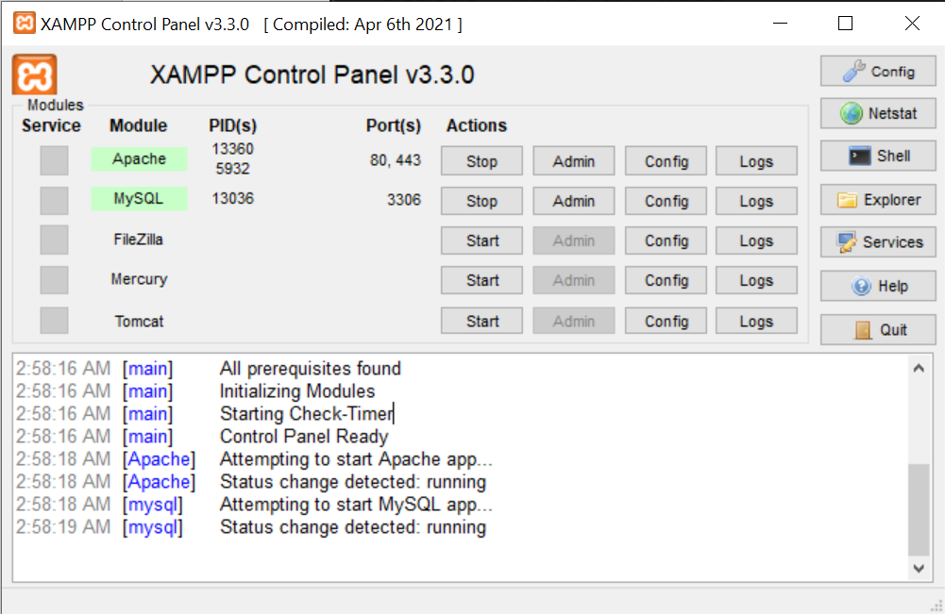

XAMPP for Local Hosting

**For complete code with comments please visit our GitHub repository**

<https://github.com/Anuraag-23/MiniProject-Sem-III>

**5 TESTING AND RESULTS**

**5.1 SIGN-UP PAGE:**

The whole website is a responsive one, with the facility of contributing to the community. The registration page is responsive and user-friendly. It can be easily understood by a layman.

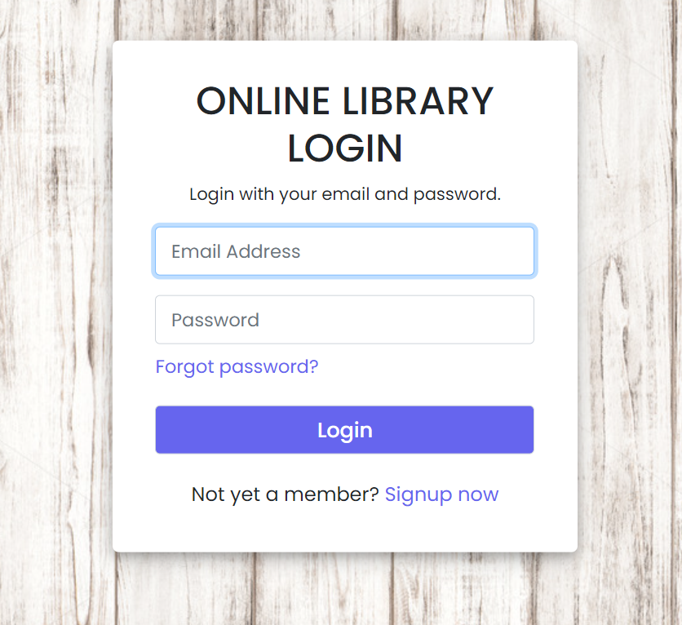 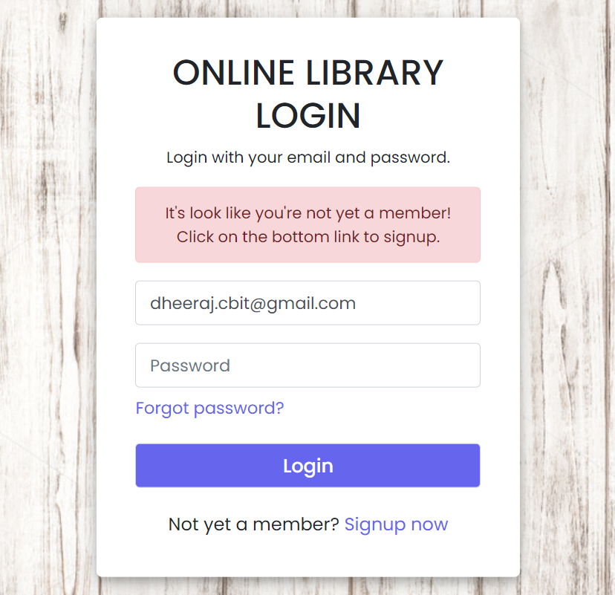

(i) Login Page (ii) If not registered user

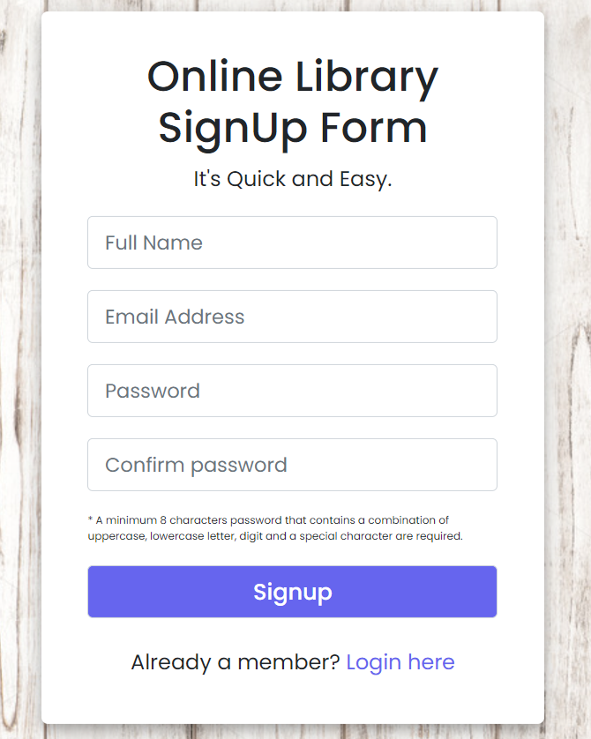 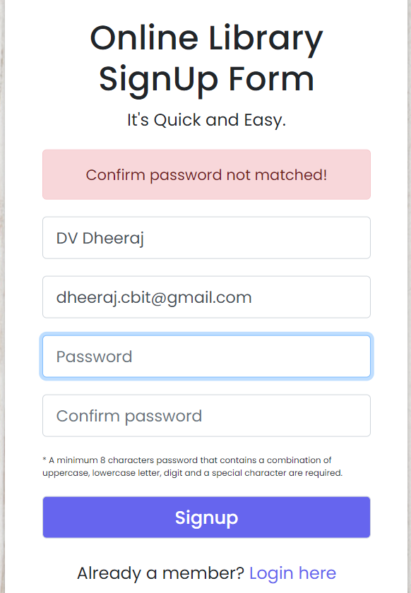 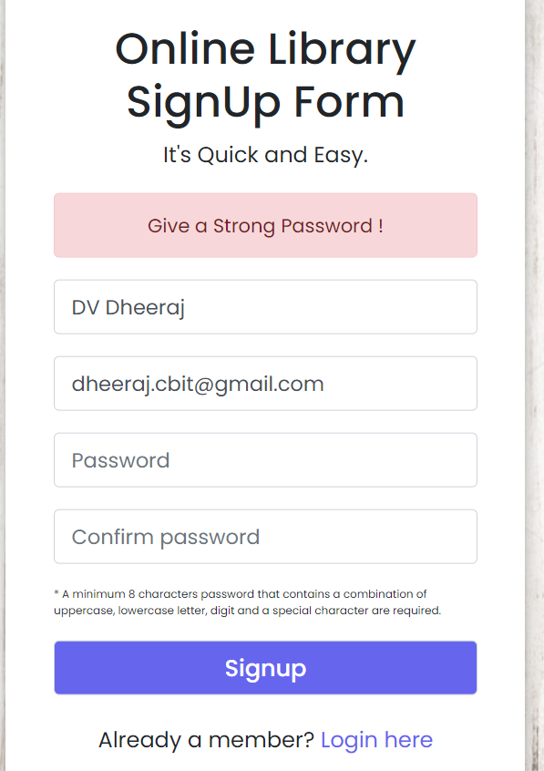

(iii) Sign-Up Page (iv) Confirm Password Not matched (v) Password not Strong

**OTP PAGE**

A One-Time Password will be sent to the user, once he registers with e-mail.

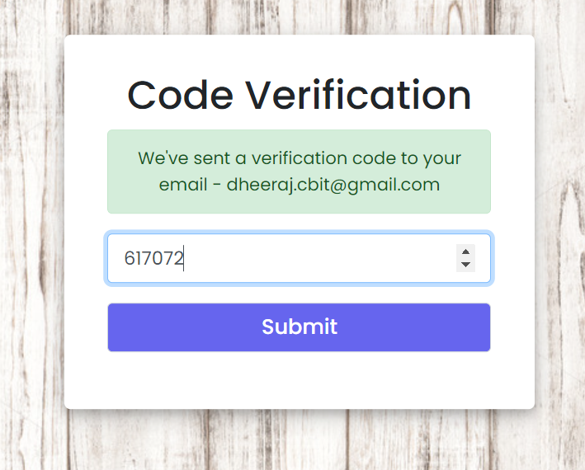 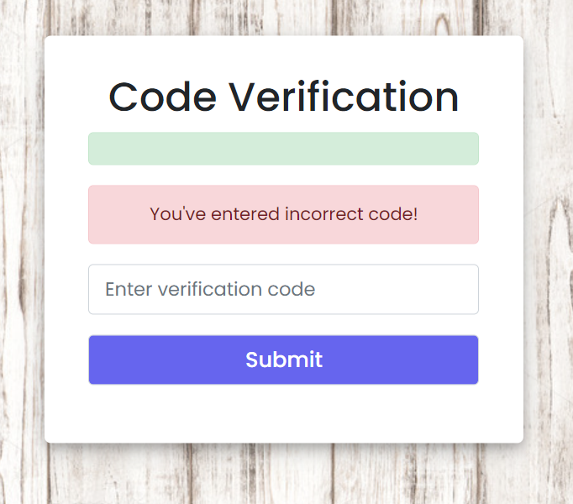

(vi) OTP Page User Verification (vii) Incorrect OTP Entered

**5.2 LOGIN PAGE**

User must get registered to login with us. To get access to out dashboard user must enter the correct email and password.

 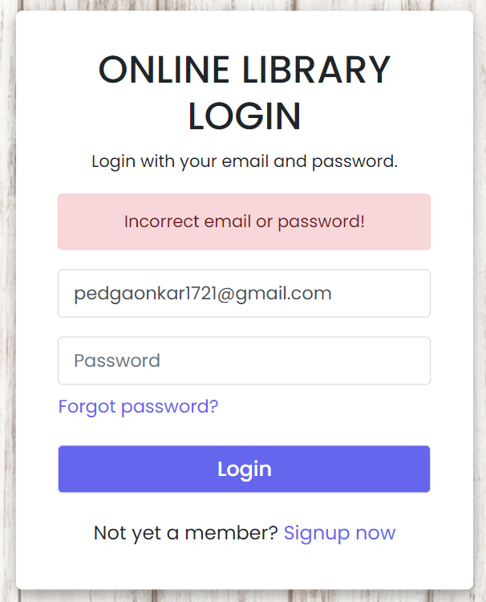

(viii) Login Page (ix) Incorrect Password

**5.3 FORGOT PASSWORD**

If user forgets his/her password, they can enter the mail with which they registered.

A reset OTP is sent to the user’s mail. User needs to enter the correct OTP to change the password.

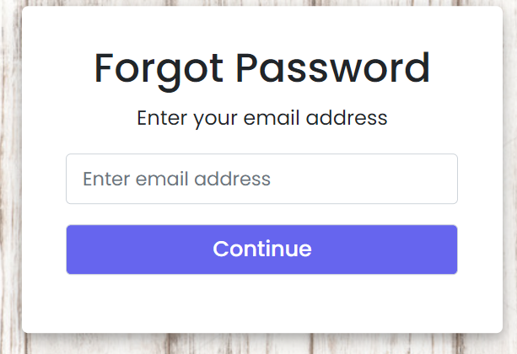 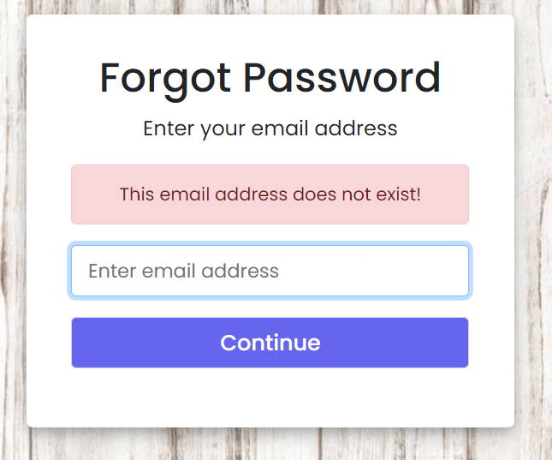

(x) User needs to enter mail (xi) If mail is not registered

**RESET OTP**

Ig user entered correct OTP he would be given access to change the Password.

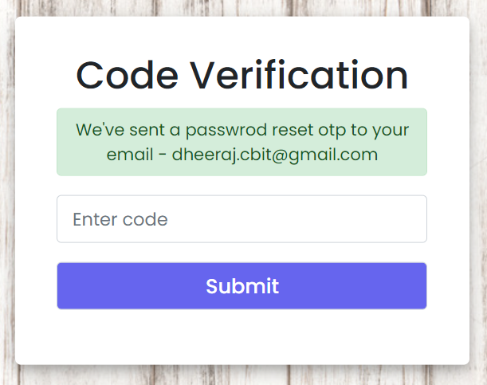

(xii) Reset OTP

**NEW PASSWORD**

User has to enter a new password which meets the pasword constraints

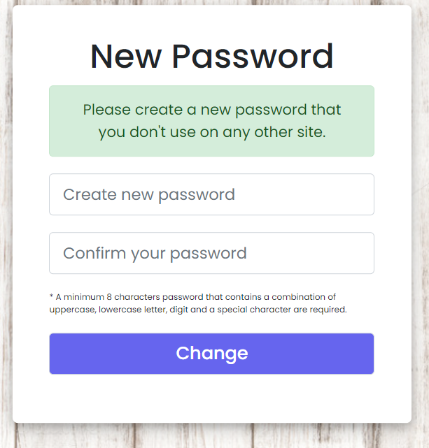

(xiii) New Password

**PASSWORD-CHANGED PAGE**

Upon successful password change the user can login with the new password provided.

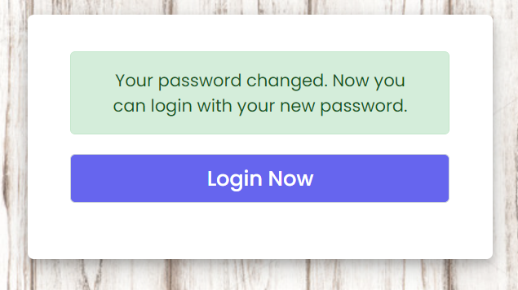

(xiv) Login-Now

**5.4 HOME PAGE**

As soon as a user login the home page is displayed in which the main content of the library is visible. There are four buttons which are displayed namely: home, help us, about us and logout with their respective functionalities. There will be a welcome sign which displays the sign along with the name of the user. The list of books will be displayed to the student’s department wise. All the books related to one department are sorted and displayed in order. After accessing a book, a user has the function to download books.

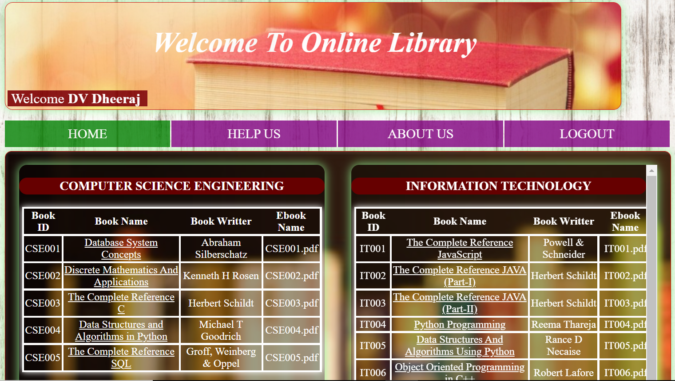

(xv) Dashboard



(xvi) List of Books (Department Wise)

**View Book Page**

After clicking on the book name from the table user can view the description of the book.



(xvii) Description of the Book

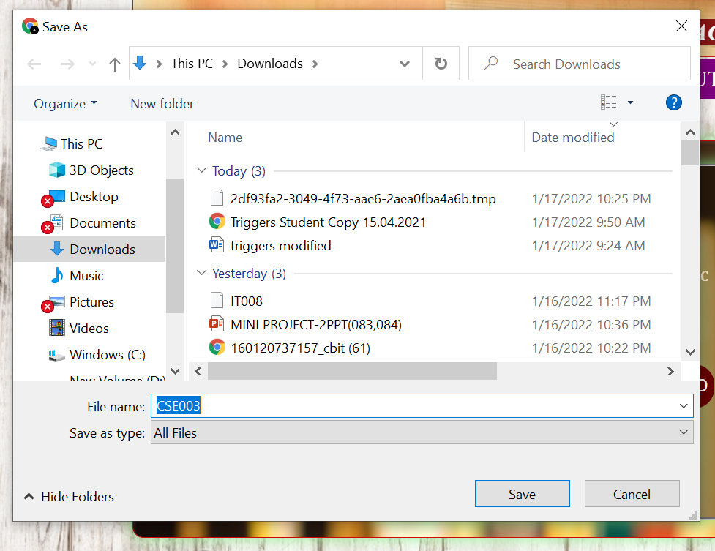

(xviii) Download the eBook

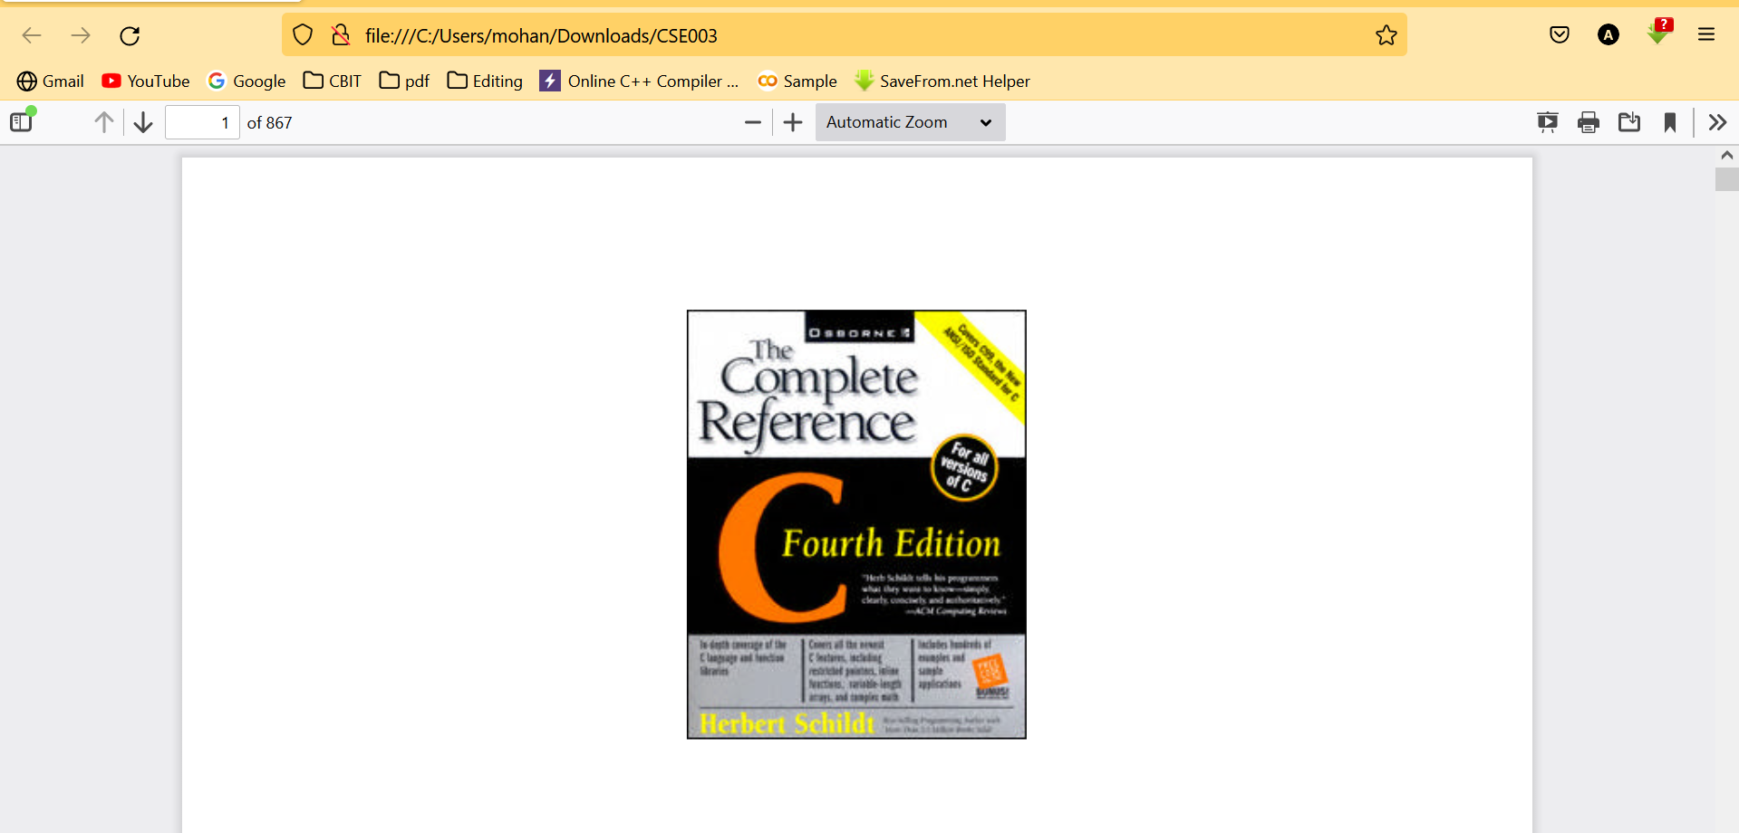

(xix) Downloaded book on local system

**5.5 HELP US**

As this project is emphasized on open contribution, we believe that it’s the collective responsibility of the students to contribute towards this project. Hence a dedicated help us page was added to this web site. In this web page a step-by-step procedure is there to guide the students to add books. Even any changes or suggestions can be mailed to the admin.

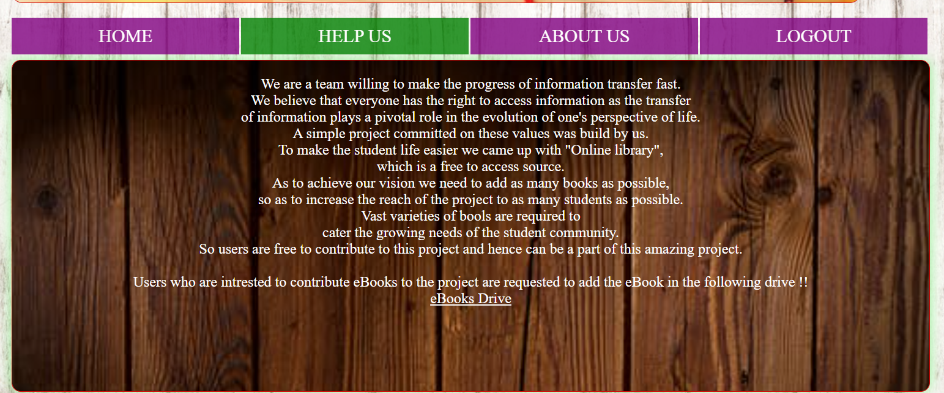

(xx) Help Us

**ABOUT US PAGE**

Users can view the acknowledgement of the project. Group members involved in making the project.

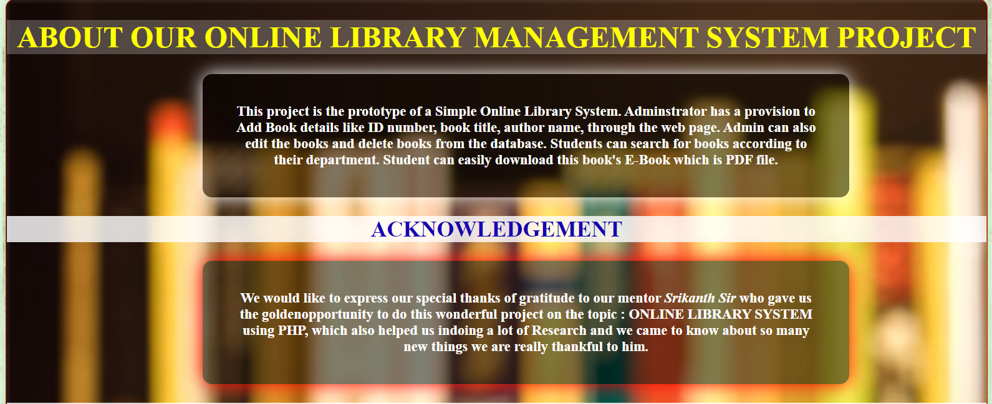

(xxi)Acknowledgement (About-Us)

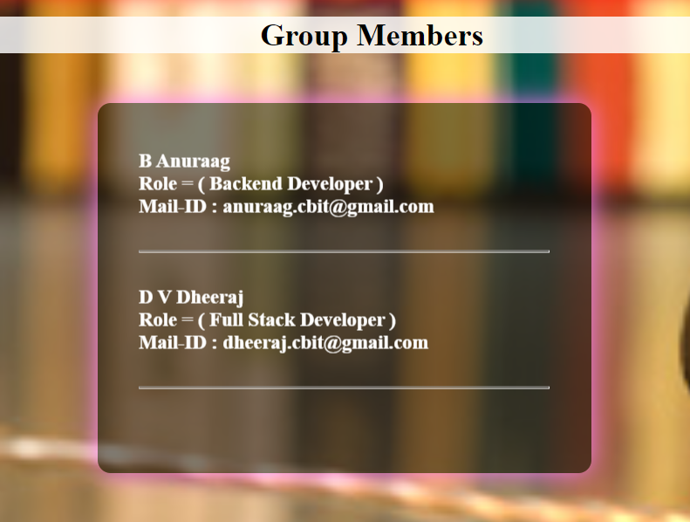

(xxii) Group Members

**5.6 ADMIN VIEW PAGE**

The admin can view all the books available on the online library.

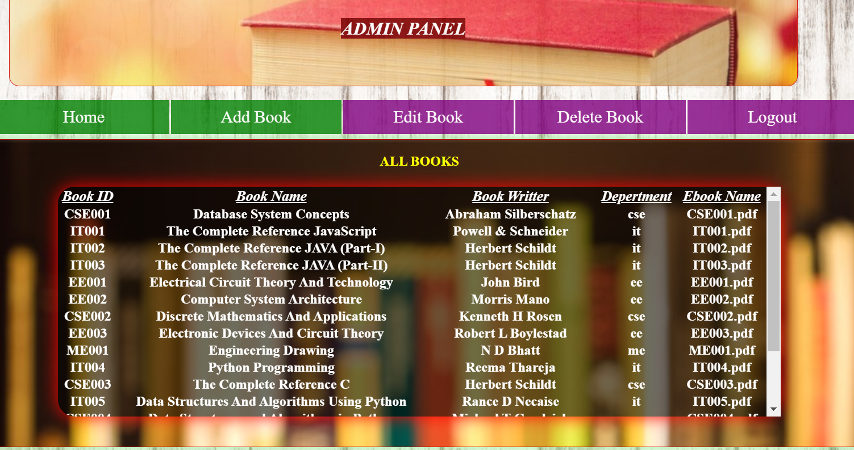

(xxii) Admin View Page

**ADD BOOK PAGE**

Admin can add new book by specifying its Book id, Book name, Author name, Department.

Then Admin can choose file from local system to upload.

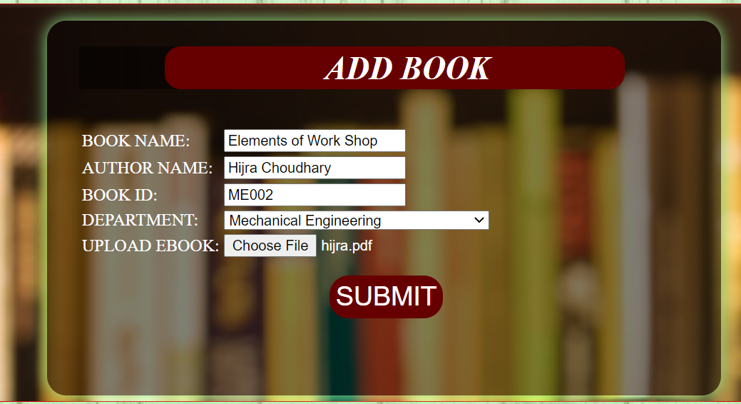

(xxiii) Add Book Page

**EDIT BOOK**

Admin can edit a book suppose if a new edition is available. Admin needs to provide description of the book and can re-upload the book.

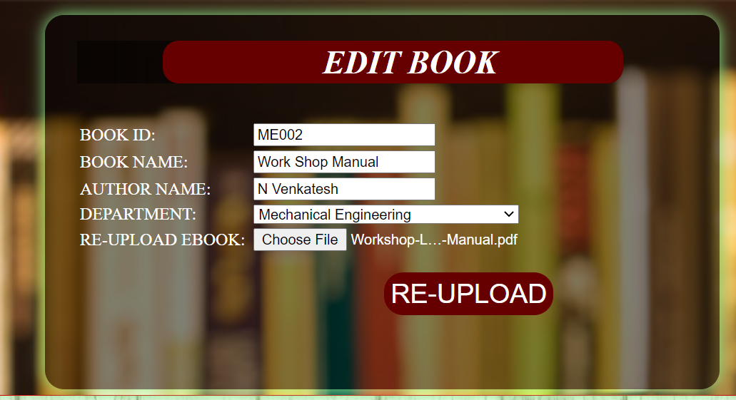

(xxiv) Edit Book Page

**DELETE BOOK**

Admin can delete a book from database providing its Book Id.

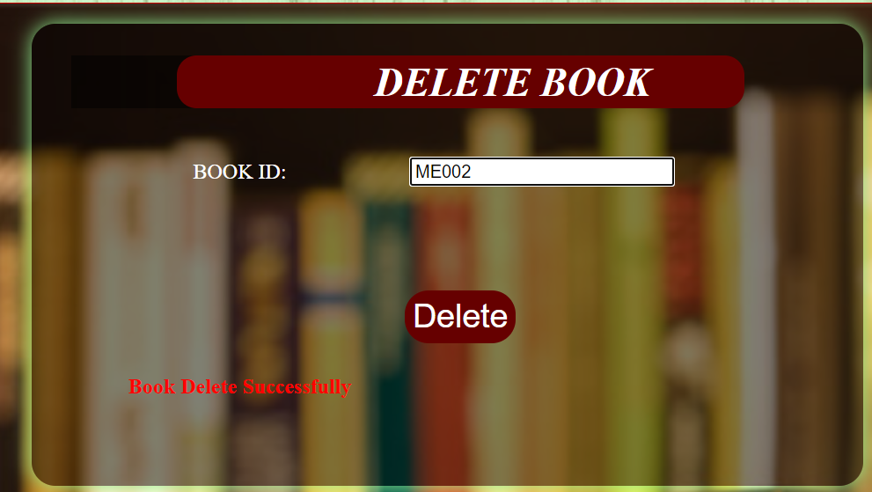

(xxv) Delete Book

**6 CONCLUSION AND FUTURE SCOPE**

**6.1 CONCLUSION:**

This project is a unique one for the team and students as it plays a pivotal role in the transfer of knowledge within no time. This is a good opportunity for the student community to utilize the resources of this project. This Library can bypass so many constraints and can become a boon to the student community. According to research done by Pew, 76 percent of the students wanted to switch to digital libraries in 2020. So, it was the right timing for us to capitalize on this project.

**6.2 Limitations:**

The main limitations of this project are that there is a need for either cloud storage or servers to maintain a large amount of data. The second feature which can be considered as a limitation is to improve more security constraint.

**6.3 FUTURE SCOPE:**

Our project satisfies all the needs which should be required for a “Online Library”. This project can be extended further by cloud connectivity. Our project can be extended to whole student community in the state, rather than confining to a specific college. As of now this project is meant for only educational purposes. This can be extended to different genres and can be diversified more.

**BIBLIOGRAPHY**

[1] <https://www.cloudways.com/blog/connect-mysql-with-php/>

[2] <https://www.simplilearn.com/tutorials/php-tutorial/php-login-form>

[3] <https://www.geeksforgeeks.org/passwords-and-cryptographic-hash-function/>

[4] <https://www.youtube.com/watch?v=h-i5rZwlfu4>